**NDIS Support Agreement**

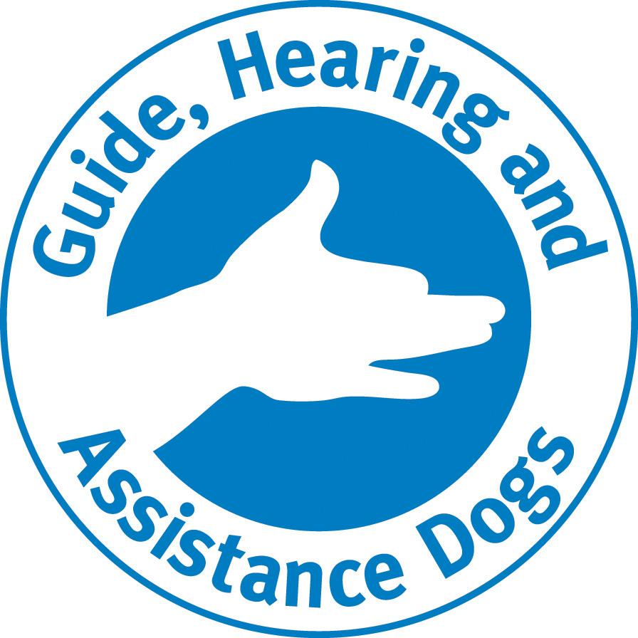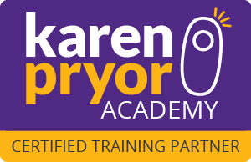

Welcome to Playful Paws ®, we support people with a disability to access the community. We also provide Animal Assisted Therapy with our qualified trainers and therapy dogs. Please do not hesitate to contact us should you have any questions.

Please forward completed form to [accounts@playfulpaws.com.au](mailto:accounts@playfulpaws.com.au) or return in person to 6 Macleod Street, Bairnsdale.

Megs & Playful Paws Team.

| **Participant Details** | | |
| --- | --- | --- |
| Participant Name: |  | |
| Participant NDIS Number: |  | |
| Participant Mobile: |  | |
| Participant Email: |  | |
| Participant’s Residential Address: |  | |
| Postal Address (if applicable) |  | |
| **Participant’s Nominated Representative (if applicable)** | | |
| Name: |  | |
| Phone Number: |  | |
| Email: |  | |
| **Supports Offered - Line Item to use** | | |
| Private Training | Group classes | Therapy Dog Visit |
| **Consumables - Line Item to use** | | |
| **Payment for Requested Services** | | |
| Plan Management Provider: |  | |
| Phone Number: |  | |
| Email Address: |  | |
| **Support Coordinator** | | |
| Phone / Email: |  | |